**CHAMELI DEVI GROUP OF INSTITUTIONS**

**INDORE (M.P.)**



**Online Cafe**

**Mini Project Report**

**CS504[A]- Internet and Web Technology**

**Submitted By:**

Krish Chandel (0832CS211105)

Krish Sen (0832CS211106)

Kuldeep Chawada (0832CS211107)

Kuldeep Patidar (0832CS211108)

Lokesh Chandra Dongre (0832CS211110)

**Guided By:**

Prof. Dharmendra Pathak

Asst. Professor, CSE Dept.

CDGI Indore

**DEPARTMENT OF COMPUTER SCIENCE & ENGINEERING**

**CHAMELI DEVI GROUP OF INSTITUTIONS**

**INDORE (M.P.)**



**DEPARTMENT OF COMPUTER SCIENCE & ENGINEERING**

**CERTIFICATE**

This is to certify that Mr. Krish Chandel, Krish Sen, Kuldeep Chawada, Kuldeep Patidar, Lokesh Chandra Dongre with RGTU Enrollment No. 0832CS211105, 0832CS211106, 0832CS211107,0832CS211108, 0832CS211110 have satisfactorily completed the Mini Project on **“Online Café (The Tweek’s)”** in **“CS504[A]-Internet and Web Technology”**, for **B. Tech, Vth Semester** of the **Computer Science & Engineering** during year **2023 – 24**.

__________________________

**Signature of Signature of**

**Head of the Department Faculty In-charge**

**TABLE OF CONTENTS**

|  |  |
| --- | --- |
| **CONTENTS** | **PAGE NO.** |
| Introduction of the Project | 4 |
| Description of the Project | 5 |
| Technical Details of the Project | 6 |
| Screenshot of the Code | 7-8 |
| Screenshot of working Project | 9-11 |
| References | 12 |

**Introduction of the Project**

In the dynamic landscape of the 21st century, technological advancements continue to redefine the way we interact with the world around us. The food and beverage industry, a cornerstone of socialization and cultural experience, has not been immune to this digital revolution. Recognizing the need for innovation in the traditional cafe model, our project introduces the "Online Cafe Management System" - a comprehensive solution designed to modernize and streamline cafe operations, enhance customer experiences, and adapt to the evolving demands of the digital era.

Cafes, once synonymous with leisurely gatherings and aromatic brews, now face the challenge of meeting the expectations of a tech-savvy clientele. The Online Cafe addresses this challenge head-on by providing an efficient and user-friendly platform that seamlessly integrates the physical and digital aspects of the cafe experience.

The Tweek’s was conceived in response to the growing need for a more efficient and customer-centric approach to cafe management. Traditional cafes often face challenges such as manual order processing, cumbersome reservation systems, and limited accessibility to the menu. To address these issues, our project envisions a comprehensive solution that not only enhances the customer experience but also optimizes the operational aspects of running a cafe.

**Description of the Project**

**1. User-Friendly Ordering Platform:**

The project focuses on delivering a user-friendly interface that makes the food ordering process straightforward and enjoyable. Customers can easily navigate through the online platform, view the cafe's menu, and place orders with just a few clicks. The design prioritizes simplicity to cater to a diverse range of users.

**2. Interactive Menu Exploration:**

The system offers an interactive menu that showcases a variety of dishes and beverages. Customers can browse through the menu, access detailed descriptions, and view images to make informed decisions. The platform ensures that users can easily explore the cafe's offerings and discover new items.

**3. Customizable Orders:**

Recognizing the diversity of customer preferences, the project allows users to customize their orders based on personal taste, dietary restrictions, or specific requests. The customization feature enhances the customer experience by providing a tailored and satisfying food ordering process.

**4. Secure Online Transactions:**

Security is a paramount concern in the project, and it implements secure online transactions to safeguard customer information. The ordering system is designed to protect user data and ensure a safe and trustworthy digital transaction process.

**5. Real-Time Order Tracking:**

The Online Cafe incorporates real-time order tracking, allowing customers to monitor the progress of their orders. This feature enhances transparency and provides customers with timely updates on the status of their food, reducing uncertainty and improving overall satisfaction.

**Technical Details of the Project**

Some technical details of our online cafe project are:-

**1. Frontend Development: -**

* **User Interface (UI):** You'll need a clean and intuitive UI to display the menu, take orders, and show store locations. This could be built using HTML, CSS, and JavaScript.
* **Frameworks:** Consider using a framework like React or Vue.js for a more efficient development process and a responsive design.

**2. Backend Development:-**

* **Server:** A server to handle requests from the client side. This could be built using Node.js, Django.
* **Database:** To store menu items, order details, and store locations, a database is required. We can use SQL (like MySQL or PostgreSQL) or NoSQL (like MongoDB) databases.

**3. APIs: -**

* **Store Locator:** We'll need to integrate with a mapping service API (like Google Maps API) to display your store locations. –
* **Payment Gateway:** To handle online payments, we'll need to integrate with a payment gateway API like Stripe or PayPal.

**4. Security: -**

* **Authentication:** Implement user authentication to allow users to have accounts, track their orders, and potentially offer personalized recommendations. This could be done using OAuth or JWT.
* **Data Encryption:** Ensure that sensitive data, especially related to payments, is encrypted using protocols like SSL/TLS.

**5. Testing & Deployment :-**

* **Testing:** Use testing frameworks (like Jest for JavaScript, or PyTest for Python) to write unit tests and integration tests to ensure your application works as expected. –
* **Deployment:** Consider using a cloud service provider like AWS, Google Cloud, or Azure for deploying your application. You might also need to consider containerization (like Docker) and orchestration systems (like Kubernetes).

**Screenshot of the Code**

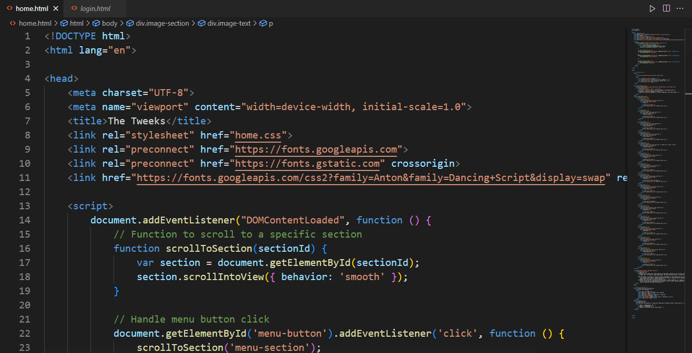

**Screenshot-1**

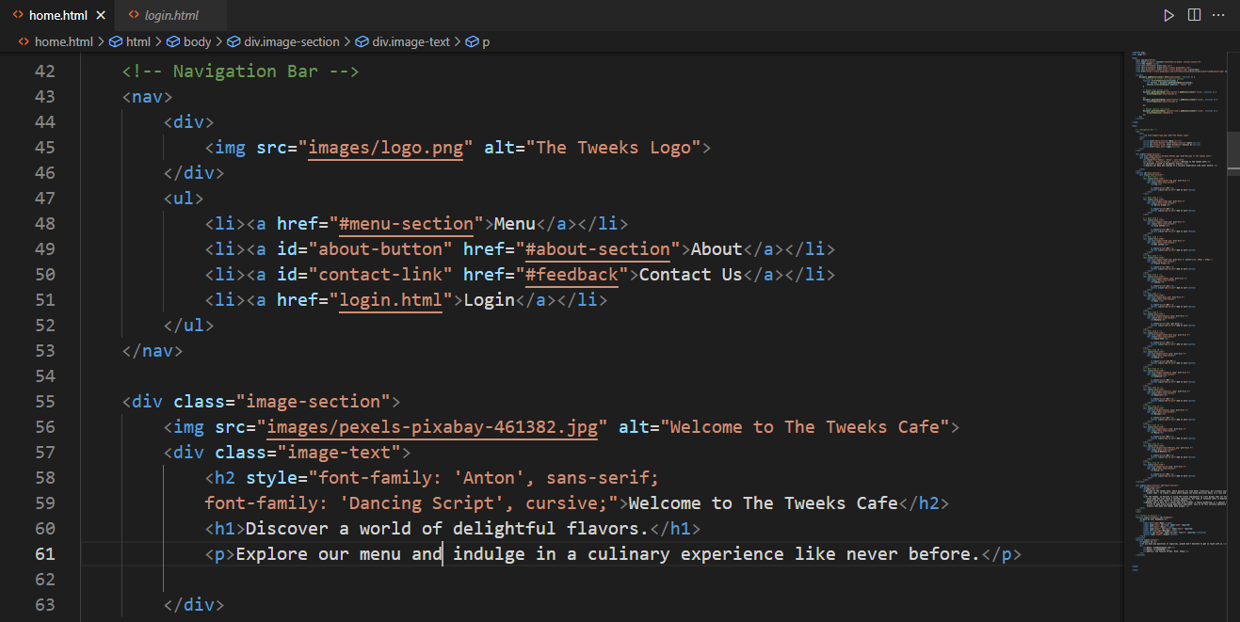

**Screenshot-2**

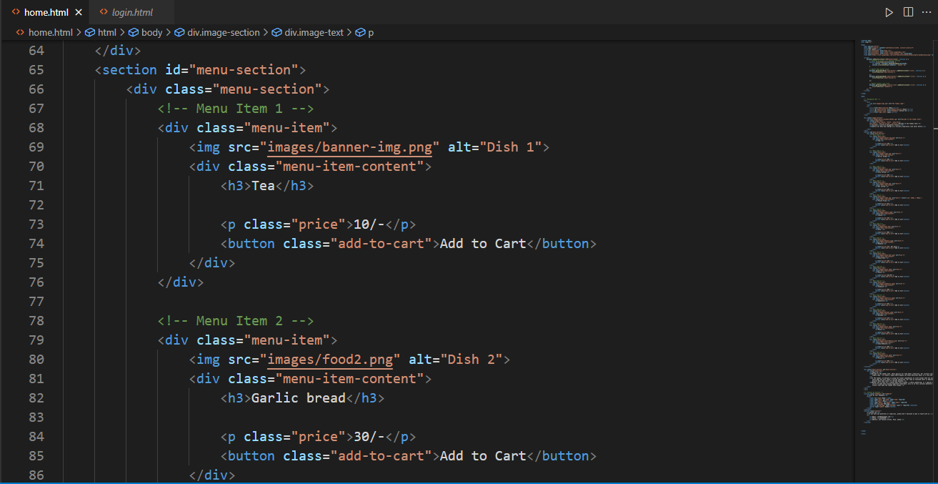

**Screenshot-3**

**Screenshot of working Project**

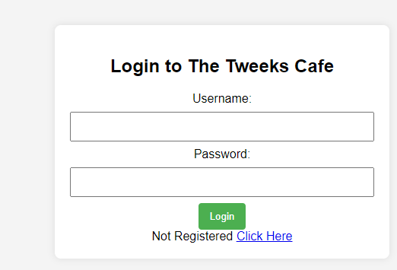

**Screenshot-1**

**Screenshot-2**

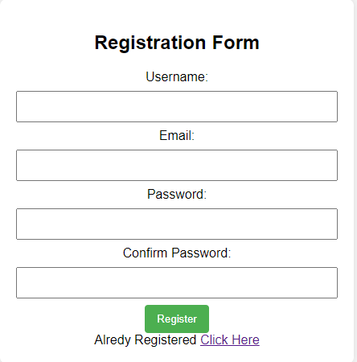

**Screenshot-3**

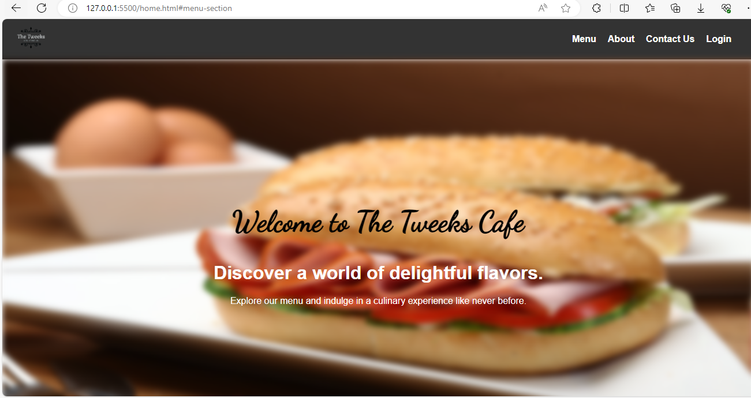

**Screenshot-4**

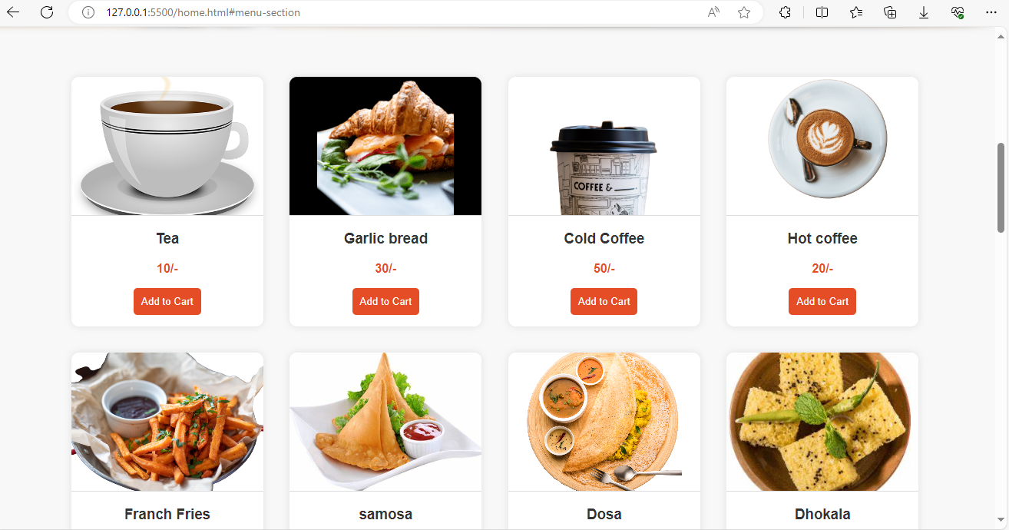

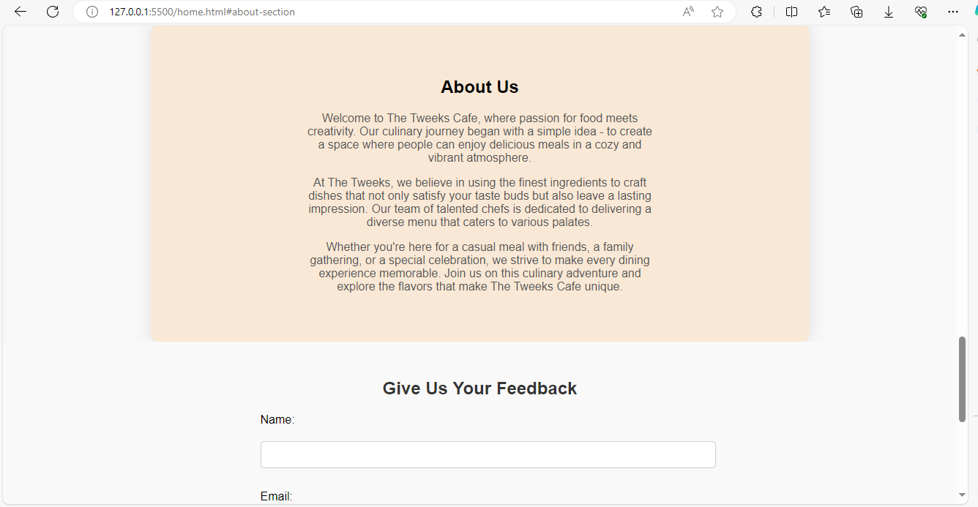

**Screenshot-5**

**References**

* <https://github.com/topics/restaurant-website>
* <https://github.com/topics/food-website>
* <https://github.com/erickdc7/coffee-shop-website-design>
* <https://github.com/varadhancst/Cafe-website>